
COMSATS University Islamabad,
Abbottabad Campus
SOFTWARE REQUIREMENTS SPECIFICATION
(SRS DOCUMENT)
for
SignSpeak: Word-Level Pakistan Sign Language Recognition
Version 1.0
By
AbuZar Babar (CIIT/FA22-BSE-133/ATD)
Mohib Ullah Khan Sherwani (CIIT/FA22-BSE-125/ATD)
M. Abdullah Umar (CIIT/FA22-BSE-126/ATD)
Supervisor
Dr. Rab Nawaz Jadoon

Bachelor of Science in Computer Science (2022-2026)

Table of Contents
1. Introduction 7
1.1 Purpose 7
1.2 Scope 7
2. Overall description 8
2.1 Product Perspective 8
2.2 Operating Environment 8
2.3 Design and Implementation Constraints 10
3. Requirement identifying technique 11
3.1 Use case diagram 11
3.2 Use case description 13
UC-1: Register Account 13
UC-2: Login 14
UC-3: Capture Frames for Translation 15
UC-4: Switch Camera Source (Front/Back) 16
UC-5: Adjust Font Size 16
UC-6: Manage Profile 17
UC-7: View Dictionary 18
UC-8: Submit Complaint 19
UC-9: Logout 20
UC-10: Perform Landmark Detection 20
UC:11 Run ML Inference (PSL Word Recognition) 21
UC:12 View Registered Users 22
UC-13: View & Manage Complaints 23
UC-14: Respond to complaints 24
4. Functional Requirements 25
FR-1: Register Account 25
FR-2: Login 25
FR-3: Capture Frames 26
FR-4: Switch Camera Source 26
FR-5: Adjust Font Size 27
FR-6: Manage Profile 27
FR-7: View Dictionary 28
FR-8: Submit Complaint 28
FR-9: Logout 29
FR-10: Detect Landmarks 29
FR-11: Infer using Model 30
FR-12: View Registered Users 30
FR-13: View Complaints 31
FR-14: Respond to Complaint 31
5. Non-Functional Requirements 32
5.1 Usability Requirements 32
5.2 Performance Requirements 32
5.3 Reliability & Availability 32
5.4 Security & Privacy Requirements 33
5.5 Portability Requirements 33
5.6 Maintainability Requirements 33
6. Gantt Chart 34
7. References 35

List of Tables

Table 1: UC-1 Register Account 11
Table 2: UC-2 Login 12
Table 3: UC-3 Capture Frames for Translation 13
Table 4: UC-4 Switch Camera Source 13
Table 5: UC-5 Adjust Font Size 14
Table 6: UC-6 Manage Profile 15
Table 7: UC-7 View Dictionary 15
Table 8: UC-8 Submit Complaint 16
Table 9: UC-9: Logout 17
Table 10: UC-10 Landmark Detection 17
Table 11: UC-11 Run ML Inference 18
Table 12: UC-12 View Registered Users 19
Table 13: UC-13 View and Manage Complaints 20
Table 14: UC-14 Respond to Complaints 20
Table 15: FR-1 Register Account 21
Table 16: FR-2 Login 22
Table 17: FR-3 Capture Frames 22
Table 18: FR-4 Switch Camera Source 22
Table 19: FR-5 Adjust Font Size 23
Table 20: FR-6 Manage Profile 23
Table 21: FR-7 View Dictionary 24
Table 22: FR-8 Submit Complaint 24
Table 23: FR-9 Logout 25
Table 24: FR-10 Detect Landmarks 25
Table 25: FR-11 Infer using Model 26
Table 26: FR-12 View Registered Users 26
Table 27: FR-13 View Complaints 27
Table 28: FR-14 Respond to Complaint 27

List of Figures
Figure 1: Usecase diagram 12
Figure 2: Gantt Chart 32

Revision History
Name | Date | Reason for changes | Version

Application Evaluation History

Comments (by committee)  *include the ones given at scope time both in doc and presentation | Action Taken

Supervised by
Dr. Rab Nawaz Jadoon
Signature______________

Introduction

1.1 Purpose
The purpose of this Software Requirements Specification (SRS) is to define the functional, non-functional, technical, and operational requirements for SignSpeak, a mobile-based Pakistan Sign Language (PSL) recognition system.
SignSpeak enables users to translate PSL gestures into text using a mobile application that captures camera frames and sends them to a backend server for processing. The system supports secure authentication using Firebase, a user complaint management feature stored in Firebase Firestore, and an admin dashboard for managing users and complaints.
This document will guide developers, stakeholders, and evaluators throughout design, implementation, testing, and deployment of the system.

1.2 Scope
The SignSpeak system includes:
Mobile Application (Flutter)
- User registration & login using Firebase Authentication
- Camera frame capture
- Sending frames to backend for ML inference
- Displaying predicted PSL words returned by backend
- Submitting complaints
Backend Server (FastAPI / Python)
- Receives camera frames from frontend
- Performs landmark detection using MediaPipe
- Executes ML model to classify PSL word
- Sends prediction response to mobile app
- Provides APIs for admin dashboard
Admin Dashboard (Web Application)
- View and manage user accounts
- View, filter, and resolve user complaints
- Monitor system usage and model performance
- Provides administrative tools for maintenance

Out of Scope
- No on-device landmark detection
- No speech synthesis or multi-language translation
- No continuous sentence-level recognition
- Real-time performance can’t be guaranteed
- No chat history

Overall description

2.1 Product Perspective
SignSpeak acts as a bridge between Deaf/Hard-of-Hearing users and hearing individuals by providing real-time PSL word recognition. The system is designed to run efficiently on mid-range smartphones by offloading all heavy computation to the backend.
High-Level Operation Flow
- User logs in via Firebase
- User opens translation screen
- Camera frames are captured
- Frames sent to backend
- Backend performs MediaPipe > ML inference
- Predicted word returned to app
- User views result
- User may copy translation or file a complaint

2.2 Operating Environment
The SignSpeak system must operate within the following environments and technical boundaries:
Mobile Application Environment
- Platforms:
  - Android 10 and above
- Hardware Requirements:
  - Camera-enabled smartphone
  - Stable internet connection (required for inference)
- Runtime:
  - Flutter SDK (current stable release)
Backend Server Environment
- Operating System:
  - Ubuntu 20.04+
- Components:
  - FastAPI (Python 3.9+)
  - MediaPipe for landmark extraction
  - TensorFlow model for PSL classification
- Hardware:
  - CPU-only server acceptable for lightweight models
  - GPU recommended for scaling and low-latency inference
- Protocols:
  - HTTP for frame transmission
Firebase Services
- Firebase Authentication:
Handles user registration and login for the mobile app.
- Firebase Firestore:
Stores user complaints and admin responses.
Admin Dashboard Environment
- Supported Web Browsers:
  - Google Chrome (latest 5 versions)
  - Firefox (latest 5 versions)
  - Microsoft Edge (latest 5 versions)
- Hosting Options:
  - Firebase Hosting
  - Any Linux-based web server with HTTPS/HTTP

2.3 Design and Implementation Constraints
The development of SignSpeak is subject to the following constraints:

Framework & Technology Constraints
CO-1: The mobile application shall be developed using Flutter (Dart), as required by project guidelines.
CO-2: The backend shall use FastAPI (Python) to support asynchronous processing and easy ML integration.
CO-3: All sign recognition shall use MediaPipe for landmark detection, as it is the chosen library and the ML model is trained on MediaPipe-compatible inputs.

Infrastructure Constraints
CO-4: All processing must occur on the backend server.
CO-5: The ML model must be deployed in TensorFlow format due to training pipeline compatibility.

Firebase Constraints
CO-6: User authentication must use Firebase Authentication, as it is the official identity provider for the project.
CO-7: User complaints must be stored in Firebase Firestore only, not a local database.

Security Constraints
CO-8: All frame transmissions must be encrypted over HTTP/HTTPS,
CO-9: Backend must not store raw video frames unless explicitly enabled for debugging.

Requirement identifying technique
The requirements for the SignSpeak system have been identified primarily through Use Case Modeling, which is appropriate for interactive end-user systems involving real-time user actions, backend responses, and administration workflows.
Since SignSpeak is a mobile application with real-time user interaction and server communication, Use Cases are the most effective technique for identifying system requirements. They clearly represent interactions between:
- Users (end users, admin)
- Mobile application
- Backend server
- Firebase services
This technique ensures that all functional requirements are derived from how actors expect to use the system.

3.1 Use case diagram

Primary Actor
- User (Mobile App User)
- Admin User (Dashboard)
Secondary Actors
- Backend Server (Inference Engine)
- Firebase Authentication Service
- Firebase Firestore (Complaint Storage)

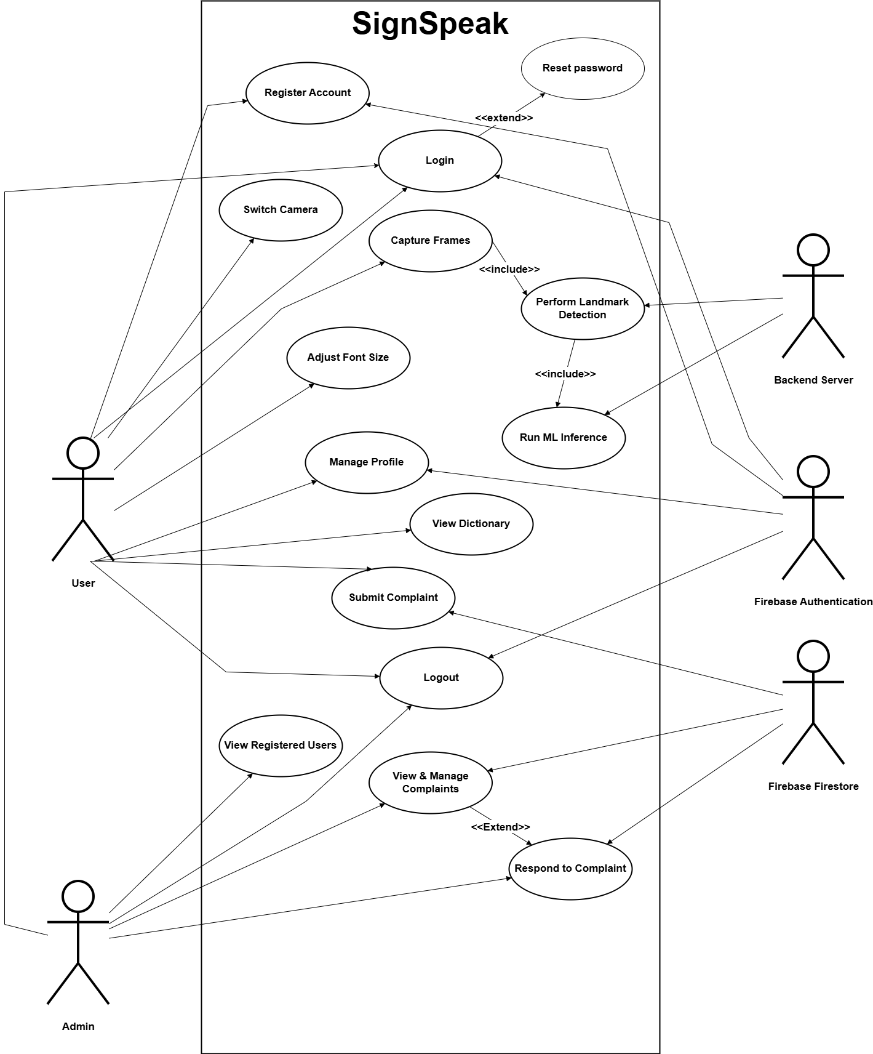
Figure 1: Usecase diagram

Use case description

UC-1: Register Account
The following Table 1 gives the detailed description of the use case User Registration.
Table 1: UC-1 Register Account
Field | Description
Use Case ID | UC-1
Use Case Name | Register
Primary Actor | User
Secondary Actors | Firebase Authentication
Description | The user creates a new account in the SignSpeak application by providing required registration details. Firebase Authentication creates a new user record and returns a verification response.
Trigger | User taps the Register button on the authentication screen.
Preconditions | PRE-1: User has a valid email address. PRE-2: Internet connection is available.
Postconditions | POST-1: A new user account is created in Firebase Auth. POST-2: User is redirected to the login screen.
Normal Flow | 1. User selects Register. 2. App displays registration form. 3. User enters email, password. 4. App sends registration data to Firebase. 5. Firebase creates a new user account. 6. App displays “Registration Successful”. 7. User is redirected to login or automatically logged in.
Alternative Flows | AF-1: User enters already-registered email 1. Firebase returns “Email already in use”. 2. App prompts user to log in instead.
Exceptions | E1: Weak password > Firebase returns error. E2: Internet unavailable > Registration fails and retry option shown.
Business Rules | BR-1: Password must be minimum 6 characters. BR-2: Email must follow valid email format. BR-3: Duplicate emails not allowed.
Assumptions | A-1: Majority of new users register with email/password.

UC-2: Login
The following Table 2 gives the detailed description of the use case User Login.
Table 2: UC-2 Login
Field | Description
Use Case ID | UC-2
Use Case Name | Login
Primary Actor | User
Secondary Actors | Firebase Authentication
Description | The user logs into the SignSpeak mobile application using Firebase Authentication. Successful login grants access to translation, complaints, dictionary, and profile features.
Trigger | User selects the Login option.
Preconditions | PRE-1: User has internet connectivity. PRE-2: Firebase Auth service is available.
Postconditions | POST-1: User is authenticated. POST-2: Auth token is securely stored.
Normal Flow | 1. User taps Login. 2. App displays login form. 3. User enters email and password. 4. App sends credentials to Firebase. 5. Firebase verifies credentials. 6. App redirects the user to the home screen.
Alternative Flows | AF-1: User navigates to Sign up screen. User clicks the button to go back to registration screen in case they haven’t signed in.
Exceptions | E1: Invalid email or password > App displays error message. E2: Internet unavailable > Login fails, prompt user to retry.
Business Rules | BR-1: Password must be at least 6 characters. BR-2: Email must be a valid format.
Assumptions | A-1: Most users will already have an account.

UC-3: Capture Frames for Translation
The following Table 3 gives the detailed description of the use case Capture Frames.
Table 3: UC-3 Capture Frames for Translation
Field | Description
Use Case ID | UC-3
Use Case Name | Capture Frames for Translation
Primary Actor | User
Secondary Actors | Backend Server
Description | The user begins PSL translation by enabling the camera. The mobile app captures video frames and sends them to the backend server where all landmark detection and ML inference occurs.
Trigger | User taps Start Translation on the translation screen.
Preconditions | PRE-1: User is logged in. PRE-2: Camera permission granted. PRE-3: Internet connection available.
Postconditions | POST-1: Frames are transmitted continuously to backend. POST-2: Translation predictions begin returning.
Normal Flow | 1. User opens Translation screen. 2. App requests camera access. 3. Camera preview is activated. 4. App starts capturing frames at fixed intervals. 5. Frames are compressed. 6. App sends frames to backend. 7. Backend extracts landmarks and infers.
Alternative Flows | AF-1: No Sign Detected 1. System detects no sign with high enough confidence score 2. System requests user to sign.
Exceptions | E1: Camera Permission Denied > App displays permission request dialog. E2: Network Error > App retries sending frames.
Business Rules | BR-1: Frame size must be compressed below system threshold. BR-2: App must maintain at least minimum FPS for smooth capture.
Assumptions | A-1: User keeps hands visible within camera frame.

UC-4: Switch Camera Source (Front/Back)
The following Table 4 gives the detailed description of the use case Switch Camera Source.
Table 4: UC-4 Switch Camera Source
Field | Description
Use Case ID | UC-4
Name | Switch Camera Source
Actors | Primary: User
Description | User switches between front-facing and rear camera for translation.
Trigger | User taps Flip Camera icon.
Preconditions | PRE-1: Camera permission granted.
Postconditions | POST-1: Camera feed switches successfully.
Normal Flow | 1. User taps flip icon.  2. System stops current camera stream.  3. System initializes alternate camera.  4. Translation screen updates with new stream.
Exceptions | E-1: Camera in use by another app.  E-2: Selected camera unavailable.

UC-5: Adjust Font Size
The following Table 5 gives the detailed description of the use case Switch Camera Source.
Table 5: UC-5 Adjust Font Size
Field | Description
Use Case ID | UC-5
Use Case Name | Adjust Font Size
Primary Actor | User
Secondary Actors | None
Description | The user adjusts the displayed translation text size in the application for better readability and accessibility. The updated font size is immediately applied.
Trigger | User navigates to Settings and interacts with the font size slider.
Preconditions | PRE-1: User is authenticated.
Postconditions | POST-1: New font size is applied across the UI. POST-2: Updated font size stored for the sessions.
Normal Flow | 1. User opens the Settings screen. 2. User adjusts the font slider. 3. App updates the preview text dynamically. 4. User confirms the selection or leaves settings.
Exceptions | E1: App writes error > App displays “Unable to save settings” and reverts to previous font size.
Business Rules | BR-1: Font size must be within a defined min/max range (e.g., 12–32 pt).
Assumptions | A-1: User adjusts font size primarily for accessibility or visibility.

UC-6: Manage Profile
The following Table 6 gives the detailed description of the use case Manage Profile.
Table 6: UC-6 Manage Profile
Field | Description
Use Case ID | UC-6
Use Case Name | Manage Profile
Primary Actor | User
Secondary Actors | Firebase Authentication
Description | The user views and updates their profile information such as name, email. Updates are synced with Firebase Authentication and reflected in the app.
Trigger | User selects Profile from the app menu.
Preconditions | PRE-1: User is logged in. PRE-2: Firebase Authentication is available.
Postconditions | POST-1: Updated profile info stored in Firebase. POST-2: Updated UI reflects user’s changes.
Normal Flow | 1. User opens the Profile screen. 2. App fetches profile details (Include: Fetch Profile Data). 3. User edits profile fields (name, optional profile picture). 4. User confirms changes. 5. App sends updated information to Firebase (Include: Update Profile Data). 6. Firebase updates the user's profile. 7. App displays a success message.
Alternative Flows | AF1: Unable to save profile changes
Exceptions | E1: Firebase update failure > App displays retry prompt. E2: Invalid email change > Requires re-authentication.
Business Rules | BR-1: Email updates require re-authentication.
Assumptions | A-1: Users frequently update their profile for personalization.

UC-7: View Dictionary
The following Table 7 gives the detailed description of the use case View Dictionary.
Table 7: UC-7 View Dictionary
Field | Description
Use Case ID | UC-7
Use Case Name | View Dictionary
Primary Actor | User
Secondary Actors | Backend Server
Description | User browses a list of PSL words. Selecting a word opens an external PSL website explaining that sign.
Trigger | User taps Dictionary.
Preconditions | PRE-1: User is authenticated. PRE-2: Backend server dictionary is available.
Postconditions | POST-1: Dictionary words and media are displayed to the user.
Normal Flow | 1. User selects “Dictionary.” 2. App requests the list of words from backend. 3. Backend returns dictionary entries. 4. App displays words in a list/grid. 5. User taps on a word to view its details. 6. App displays PSL website link to the sign.
Alternative Flows | AF-1: User performs search 1. User types into search bar. 2. App filters dictionary results locally or via backend query.
Exceptions | E1: Backend unreachable > App shows “Unable to load dictionary.”
Business Rules | BR-1: Dictionary content must be validated/approved before being displayed. BR-2: Dictionary items should be categorized.

UC-8: Submit Complaint
The following Table 8 gives the detailed description of the use case Submit Complaint.
Table 8: UC-8 Submit Complaint
Field | Description
Use Case ID | UC-8
Use Case Name | Submit Complaint
Primary Actor | User
Secondary Actors | Firebase Firestore
Description | The user submits a complaint about incorrect translations mainly and also regarding app performance issues, bugs, or general feedback. The complaint is stored in Firebase Firestore for later review by the admin.
Trigger | User taps Submit Complaint from the menu or settings.
Preconditions | PRE-1: User is logged in. PRE-2: Firestore service is available.
Postconditions | POST-1: Complaint record is created in Firestore.
Normal Flow | 1. User opens the Complaint form. 2. User enters complaint description. 3. User taps Submit. 4. App sends complaint data to Firestore. 5. App displays “Complaint Submitted Successfully.”
Alternative Flows | AF1: Unable to save complaint, user gets updated regarding the issue and then retries.
Exceptions | E1: Firestore write failure > App prompts user to retry. E2: No internet > Complaint not saved
Business Rules | BR-1: Complaint text cannot be empty.
Assumptions | A-1: Admin checks complaints regularly.

UC-9: Logout
The following Table 9 gives the detailed description of the use case Logout.
Table 9: UC-9: Logout
Field | Description
Use Case ID | UC-9
Use Case Name | Logout
Primary Actor | User
Secondary Actors | Firebase Authentication
Description | The user logs out of the SignSpeak application, ending the current authenticated session and clearing locally stored user data.
Trigger | User taps the Logout button in the app menu or settings.
Preconditions | PRE-1: User must be logged in.
Postconditions | POST-1: Session token is removed from device. POST-2: User is redirected to the login screen.
Normal Flow | 1. User taps Logout. 2. App calls Firebase Auth sign-out method. 3. User is redirected to Login screen.
Exceptions | E1: Token clearing fails > App forces logout by resetting internal state.
Business Rules | BR-1: Logout must clear all cached personal and translation data related to the user.
Assumptions | A-1: User logs out for privacy or switching accounts.

UC-10: Perform Landmark Detection
The following Table 10 gives the detailed description of the use case Perform Landmark Detection.
Table 10: UC-10 Landmark Detection
Field | Description
Use Case ID | UC-10
Use Case Name | Perform Landmark Detection
Primary Actor | Backend Server
Secondary Actors | MediaPipe Library
Description | The backend server receives image frames from the mobile app and uses MediaPipe to extract holistic PSL landmarks (hands). These landmarks are then used for ML inference.
Trigger | Backend receives a frame (group of frames) from the mobile app for processing.
Preconditions | PRE-1: Frame must be received from the mobile app. PRE-2: MediaPipe runtime installed and functioning.
Postconditions | POST-1: Landmark array extracted. POST-2: Prepared data passed to ML inference module.
Normal Flow | 1. Backend receives a compressed frame from the mobile app. 2. Backend decodes frame. 3. Backend calls MediaPipe (Include: MediaPipe Extraction). 4. MediaPipe extracts hand, face, and pose landmarks. 5. Backend normalizes and structures these landmarks. 6. Landmark data forwarded to ML inference (UC-10).
Alternative Flows | AF-1: Partially Visible Hands 1. MediaPipe extracts incomplete landmarks. 2. Backend may do wrong prediction.
Exceptions | E1: MediaPipe detection failure > Backend returns “Landmarks Not Found.” E2: Invalid frame format > Backend discards the frame.
Business Rules | BR-1: Landmark extraction must complete within a fixed time limit to maintain low-latency translation. BR-2: Missing landmarks must be padded to maintain consistent model input shape.
Assumptions | A-1: User’s hands remain within the camera frame long enough for stable detection.

UC:11 Run ML Inference (PSL Word Recognition)
The following Table 11 gives the detailed description of the use case Run ML Inference.
Table 11: UC-11 Run ML Inference
Field | Description
Use Case ID | UC-11
Use Case Name | Run ML Inference (PSL Word Recognition)
Primary Actor | Backend Server
Secondary Actors | ML Model (TensorFlow), Landmark Detection Module
Description | After extracting landmarks from user frames, the backend server feeds these landmarks into a trained PSL gesture recognition model to generate a predicted PSL word.
Trigger | Landmark data becomes available after UC-10 completes.
Preconditions | PRE-1: Valid landmark array must be provided. PRE-2: ML model must be loaded and active in backend memory.
Postconditions | POST-1: Backend generates predicted PSL word. POST-2: Prediction is sent to mobile app.
Normal Flow | 1. Backend receives landmark data from UC-10. 2. Backend preprocesses input 3. ML model processes the data. 4. Backend obtains predicted PSL word and confidence score. 5. Backend returns prediction to the mobile app.
Alternative Flows | AF-1: Low Confidence Prediction 1. If confidence < threshold, backend marks prediction as “Low Confidence”. 2. Returns a “Could Not Recognize Sign” response.
Exceptions | E1: Model inference failure > Backend returns error to the app.
Business Rules | BR-1: Prediction confidence must accompany each returned word.
Assumptions | A-1: PSL recognition model is pre-trained and updated regularly.

UC:12 View Registered Users
The following Table 12 gives the detailed description of the use case View Registered Users.
Table 12: UC-12 View Registered Users
Field | Description
Use Case ID | UC-12
Use Case Name | View Registered Users
Primary Actor | Admin
Secondary Actors | Firebase Authentication
Description | The admin accesses the dashboard to view a list of all users registered in the SignSpeak application. The system retrieves user records from Firebase Authentication and displays them in the admin panel.
Trigger | Admin clicks "Users" section in the admin dashboard.
Preconditions | PRE-1: Admin is authenticated in the dashboard. PRE-2: Firebase Authentication service is accessible.
Postconditions | POST-1: List of registered users is displayed in the admin panel.
Normal Flow | 1. Admin logs into the admin dashboard. 2. Admin navigates to Users section. 3. Dashboard requests user list from. 4. Firebase returns list of registered accounts. 5. Dashboard displays list including name, email.
Alternative Flows | AF-1: Admin filters or searches users 1. Admin enters a keyword (email/name). 2. System filters the displayed list.
Exceptions | E1: Firebase unreachable > Display error “Unable to load users.” E2: No users found > Display empty list message.
Business Rules | BR-1: Only admins with proper privileges can view user data.
Assumptions | A-1: Admin panel has access to user info.

UC-13: View & Manage Complaints
The following Table 13 gives the detailed description of the use case View and Manage Complaints.
Table 13: UC-13 View and Manage Complaints
Field | Description
Use Case ID | UC-13
Use Case Name | View & Manage Complaints
Primary Actor | Admin
Secondary Actors | Firebase Firestore
Description | The admin accesses the complaints section of the dashboard to view, filter, and manage complaints submitted by users. Complaints are retrieved from Firebase Firestore and displayed with details such as user ID, timestamp, message.
Trigger | Admin clicks “Complaints” in the dashboard menu.
Preconditions | PRE-1: Admin is authenticated in the admin dashboard. PRE-2: Firestore is accessible.
Postconditions | POST-1: Complaints are displayed. POST-2: Admin may update complaint status.
Normal Flow | 1. Admin logs into admin panel. 2. Admin selects the Complaints section. 3. System requests all complaints from Firestore (Include: Fetch Complaints from Firestore). 4. System displays complaints with metadata (message, date, screenshot link). 5. Admin clicks a complaint to view details. 6. Admin may update status (Pending > In Progress > Resolved).
Alternative Flows | AF-1: Admin filters complaints 1. Admin applies filter (Date/User/Status). 2. System refreshes list to show filtered results.
Exceptions | E1: Firestore read error > System displays “Unable to load complaints.” E2: No complaints exist > Show empty state message.
Business Rules | BR-1: Only admins may view and modify complaints.
Assumptions | A-1: Admin reviews complaints at regular intervals.

UC-14: Respond to complaints
The following Table 14 gives the detailed description of the use case Respond to Complaints.
Table 14: UC-14 Respond to Complaints
Field | Description
Use Case ID | UC-14
Use Case Name | Respond to Complaint
Primary Actor | Admin
Secondary Actors | Firebase Firestore
Description | The admin reviews an individual complaint and updates its status (e.g., Pending > In Progress > Resolved).
Trigger | Admin selects a specific complaint from the complaints list.
Preconditions | PRE-1: Admin authenticated in admin dashboard. PRE-2: Complaint record exists in Firestore.
Postconditions | POST-1: Complaint status is updated in Firestore.
Normal Flow | 1. Admin opens a complaint from the complaints list. 2. System displays full complaint details (user info, timestamp, text). 3. Admin selects a new status (e.g., Resolved). 4. System updates the complaint document in Firestore. 5. System confirms the update.
Exceptions | E1: Firestore write failure > Admin sees “Failed to update complaint.” E2: Complaint deleted or unavailable > System notifies admin and returns to complaints list.
Business Rules | BR-1: Only Admin accounts can modify complaint status.
Assumptions | A-1: Admin will update complaints responsibly to maintain system quality.

Functional Requirements
This section lists the core functions that SignSpeak, must perform, detailing specific features and behaviors required to fulfill user needs. This section also incudes

FR-1: Register Account
Table 15: FR-1 Register Account
Field | Description
Identifier | FR-1
Title | Register Account
Description | The system shall allow a new user to create an account using email and password. Registration data is sent to Firebase Authentication, which creates a new user record and returns a success or error response.
Source | UC-1
Rationale | Required for secure access to translation, complaints, dictionary, and profile features.
Inputs | Email, Password
Outputs | Firebase user account, success/error message
Business Rules | BR-1: Password must be at least 6 characters. BR-2: Email must follow valid email format. BR-3: Duplicate emails are not allowed.
Priority | High

FR-2: Login
Table 16: FR-2 Login
Field | Description
Identifier | FR-2
Title | User Login
Description | The system shall allow users to log into the SignSpeak application using Firebase Authentication. Successful login grants access to translation, dictionary, complaints, and profile features.
Source | UC-2
Rationale | Required to authenticate the user and secure access to app features.
Inputs | Email, Password
Outputs | Authenticated session token, success/error message
Business Rules | BR-1: Password must be >= 6 characters with special characters. BR-2: Email must be in valid format.
Priority | High

FR-3: Capture Frames
Table 17: FR-3 Capture Frames
Field | Description
Identifier | FR-3
Title | Capture Frames for Translation
Description | The system shall capture camera frames, compress them, and send them to the backend server where PSL landmark extraction and ML inference are performed.
Source | UC-3
Rationale | Required to provide continuous visual input for PSL recognition and translation.
Inputs | Camera frames
Outputs | Compressed frame packets sent to backend
Business Rules | BR-1: Frames must be compressed below the defined size threshold. BR-2: The system must maintain the minimum FPS required for stable translation.
Priority | High

FR-4: Switch Camera Source
Table 18: FR-4 Switch Camera Source
Field | Description
Identifier | FR-4
Title | Switch Camera Source
Description | The system shall allow the user to switch between the front and rear camera during translation mode.
Source | UC-4
Rationale | Provides flexibility for users to select the preferred camera for signing or viewing.
Inputs | User action: Flip Camera tap
Outputs | Updated camera feed from the selected camera
Business Rules | BR-1: Camera switching must not interrupt the translation session.
Priority | Medium

FR-5: Adjust Font Size
Table 19: FR-5 Adjust Font Size
Field | Description
Identifier | FR-5
Title | Adjust Font Size
Description | The system shall allow the user to modify the font size of translated text through a slider in the settings screen. The updated font size shall be applied immediately.
Source | UC-5
Rationale | Improves accessibility and readability for users with different visual needs.
Inputs | User-selected font size value
Outputs | Updated UI text size
Business Rules | BR-1: Font size must remain within a predefined minimum and maximum range.
Priority | Medium

FR-6: Manage Profile
Table 20: FR-6 Manage Profile
Field | Description
Identifier | FR-6
Title | Manage Profile
Description | The system shall allow the user to view and update their profile information (e.g., name, email). Updates must be synchronized with Firebase Authentication.
Source | UC-6
Rationale | Allows users to personalize their account and keep their profile information accurate.
Inputs | Updated profile fields (name, email)
Outputs | Updated profile data stored in Firebase Authentication
Business Rules | BR-1: Email updates require user auth.
Priority | Medium

FR-7: View Dictionary
Table 21: FR-7 View Dictionary
Field | Description
Identifier | FR-7
Title | View Dictionary
Description | The system shall allow the user to browse a list of PSL words. Upon selecting a word, the app shall open the corresponding external PSL website link that demonstrates the sign.
Source | UC-7
Rationale | Provides users access to PSL learning material.
Inputs | User selection of dictionary item
Outputs | Dictionary list display; external PSL link opened in browser
Business Rules | BR-1: Dictionary content must be validated before display. BR-2: Dictionary items should be categorized or searchable.
Priority | Medium

FR-8: Submit Complaint
Table 22: FR-8 Submit Complaint
Field | Description
Identifier | FR-8
Title | Submit Complaint
Description | The system shall allow the user to submit complaints regarding incorrect translations, app issues, or general feedback. The complaint shall be stored in Firebase Firestore.
Source | UC-8
Rationale | Enables users to report issues and helps developers improve translation accuracy and app performance.
Inputs | Complaint text entered by the user
Outputs | Complaint record stored in Firestore; confirmation message
Business Rules | BR-1: Complaint text must not be empty.
Priority | Medium

FR-9: Logout
Table 23: FR-9 Logout
Field | Description
Identifier | FR-9
Title | Logout
Description | The system shall allow the user to log out of the application, terminating the authenticated session and clearing any locally stored user-related data.
Source | UC-9
Rationale | Ensures account privacy, security, and allows switching between accounts.
Inputs | User action: Logout tap
Outputs | User session cleared; redirect to Login screen
Business Rules | BR-1: Logout must clear cached data.
Priority | High

FR-10: Detect Landmarks
Table 24: FR-10 Detect Landmarks
Field | Description
Identifier | FR-10
Title | Detect Landarks
Description | The system (backend) shall process received image frames using MediaPipe to extract PSL-relevant holistic landmarks (hands, face). Extracted landmarks must be prepared for ML inference.
Source | UC-10
Rationale | Landmark extraction is an essential preprocessing step for accurate PSL word prediction.
Inputs | Compressed frame received from the mobile app
Outputs | Structured landmark arrays for ML inference
Business Rules | BR-1: Landmark extraction must be complete(must give output or low confidence score).
Priority | High

FR-11: Infer using Model
Table 25: FR-11 Infer using Model
Field | Description
Identifier | FR-11
Title | Infer using Model
Description | The backend server shall process extracted landmark arrays using a trained PSL gesture recognition model to predict the PSL word along with its confidence score.
Source | UC-11
Rationale | Core functionality to convert landmarks into meaningful PSL word predictions.
Inputs | Landmark array generated by the landmark detection module
Outputs | Predicted PSL word and confidence score
Business Rules | BR-1: Each prediction must include a confidence value. BR-2: Predictions below the confidence threshold must trigger a “Low Confidence” or “Unrecognized Sign” response.
Priority | High

FR-12: View Registered Users
Table 26: FR-12 View Registered Users
Field | Description
Identifier | FR-12
Title | View Registered Users
Description | The system shall allow the admin to view a list of all registered users. User records shall be fetched from Firebase Authentication and displayed in the admin dashboard.
Source | UC-12
Rationale | Allows admins to monitor platform usage and manage user-related issues.
Inputs | Admin action: View Users
Outputs | Displayed list of registered users including basic details (name, email)
Business Rules | BR-1: Only authorized admin accounts may view user data.
Priority | Medium

FR-13: View Complaints
Table 27: FR-13 View Complaints
Field | Description
Identifier | FR-13
Title | View & Manage Complaints
Description | The system shall allow the admin to view all complaints submitted by users. Complaints shall be retrieved from Firebase Firestore and displayed with relevant metadata, including user details, message, and timestamp. The admin shall also be able to update the complaint status.
Source | UC-13
Rationale | Enables effective monitoring, triage, and resolution of user-submitted complaints to maintain quality and trust.
Inputs | Admin action: View or update complaint
Outputs | Displayed complaint list; updated complaint status when modified
Business Rules | BR-1: Only admins may view or modify complaint status.
Priority | Medium

FR-14: Respond to Complaint
Table 28: FR-14 Respond to Complaint
Field | Description
Identifier | FR-14
Title | Respond to Complaint
Description | The system shall allow the admin to open an individual complaint and update its status (e.g., Pending > In Progress > Resolved). Updated status shall be stored in Firebase Firestore.
Source | UC-14
Rationale | Ensures timely response to user issues and supports structured complaint resolution workflow.
Inputs | Admin-selected status update
Outputs | Updated complaint status saved in Firestore
Business Rules | BR-1: Only authorized admin accounts can modify complaint status.
Priority | Medium

Non-Functional Requirements
This section specifies quality attributes including usability, performance, and security.

5.1 Usability Requirements
USE-1: The mobile application shall provide a clean and minimal UI that allows users to start translation within three taps.
USE-2: The app shall display large, readable text for translations, with adjustable font size for accessibility.
USE-3: Visual feedback (landmark overlays, probability bars) shall be clearly visible.
USE-4: The UI shall guide the user with prompts.
USE-5: Buttons and icons shall follow accessible sizing (minimum 48×48 px touch target).

5.2 Performance Requirements
PER-1 The system shall maintain at least 15 FPS camera preview during translation mode.
PER-2 Video or landmark data uploaded to backend shall be compressed to reduce payload size by at least 20-30%.

5.3 Reliability & Availability
REL-1 The app shall automatically pause translation if camera access is interrupted (e.g., phone call) and resume safely when available.
REL-2 The backend server shall maintain 99% uptime availability for cloud inference.
REL-3 The app shall gracefully handle recognition failures (not recognizing gestures) without crashing.

5.4 Security & Privacy Requirements
SEC-1 The app shall request explicit camera permission on first launch and shall not record or store video without user consent.
SEC-2 All communication with the backend server (landmarks, tokens, reports) shall occur via HTTP.

5.5 Portability Requirements
PORT-1 The app shall run on Android 10+.
PORT-2 The backend shall be deployable on Linux (Ubuntu 20.04+) or windows server.

5.6 Maintainability Requirements
MAINT-1 The system architecture shall follow modular design (separate modules for translation, recognition, settings).
MAINT-2 ML pipeline scripts (data collection, preprocessing, training) shall follow consistent folder structure for easy retraining.
MAINT-3 The backend API shall use versioning (v1, v2) to allow backward compatibility.
MAINT-4 Logs shall be generated for debugging (errors, model failures, server issues).

Gantt Chart
Figure 2: Gantt Chart
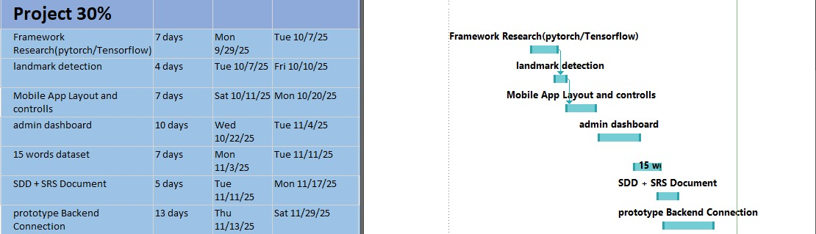
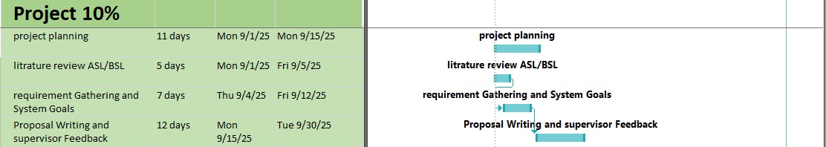
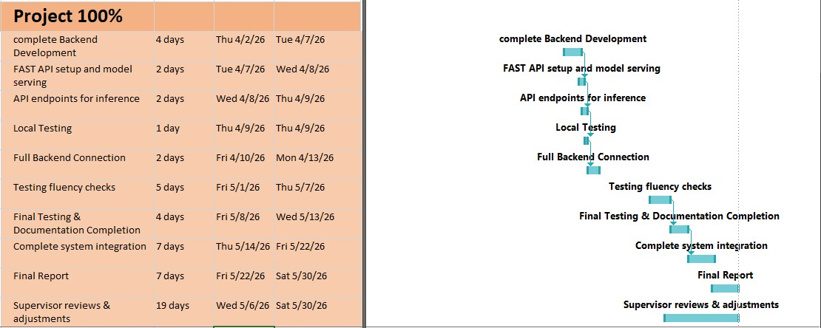
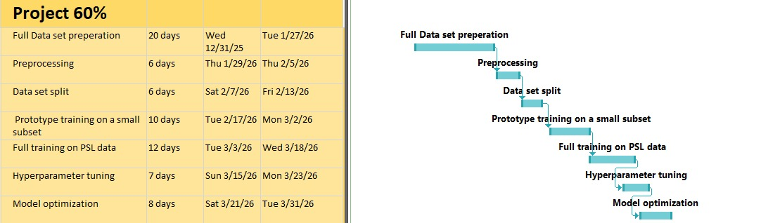

References

IEEE, “IEEE Std 830-1998: IEEE Recommended Practice for Software Requirements Specifications," New York, USA, 1998.
Hamza, H. M., & Wali, A. (2023). Pakistan sign language recognition: leveraging deep learning models with limited dataset. Machine Vision and Applications.
Imran, A., et al. (2021). Dataset of Pakistan Sign Language and Automatic Recognition of Hand Configuration of Urdu Alphabet. Data in Brief.
MediaPipe, "MediaPipe Holistic Solutions," Available: https://google.github.io/mediapipe/solutions/holistic.
Naeem, S., et al. (2025). Pakistani Word-level Sign Language Recognition Based on Deep Spatiotemporal Network. AAAI S&S.

